Assignment06
- Suppose that yearly health care expenses for a family of four are normally distributed with a mean expense equal to $3,000 and a standard deviation of $500. An insurance company has decided to offer a health insurance premium reduction if a policyholder’s health care expenses do not exceed a specified dollar amount. What dollar amount should be established if the insurance company wants families having the lowest 33 percent of yearly health care expenses to be eligible for the premium reduction?
Solution:
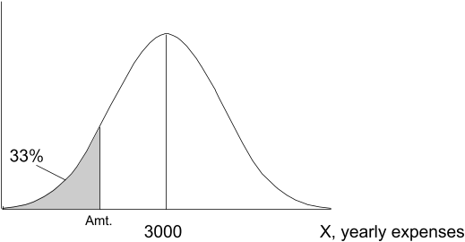
P(x ≤ k) = 0.33
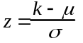
k = 2780
$2780
- A department store will place a sale item in a special display for a one-day sale. Previous experience suggests that 20 percent of all customers who pass such a special display will purchase the item. If 2,000 customers will pass the display on the day of the sale, and if a one-item-per-customer limit is placed on the sale item, how many units of the sale item should the store stock in order to have at most a 1 percent chance of running short of the item on the day of the sale? Assume here that customers make independent purchase decisions.
Solution:
P(x ≥ st) = .99
st = 441.7
442 units

- In the July 29, 2001, issue of The Journal News (Hamilton, Ohio) Lynn Elber of the Associated Press reported on a study conducted by the Kaiser Family Foundation regarding parent’s use of television set V-chips for controlling their childrens’TV viewing. The study asked parents who own TVs equipped with V-chips whether they use the devices to block programs with objectionable content.

  - Suppose that we wish to use the study results to justify the claim that fewer than 20 percent of parents who own TV sets with V-chips use the devices. The study actually found that 17 percent of the parents polled used their V-chips. If the poll surveyed 1,000 parents, and if for the sake of argument we assume that 20 percent of parents who own V-chips actually use the devices (that is, = 0.2), calculate the probability of observing a sample proportion of 0.17 or less. That is, calculate P (0.17) .

  - Based on the probability you computed in part a, would you conclude that fewer than 20 percent of parents who own TV sets equipped with V-chips actually use the devices? Explain.
Solution:
a.
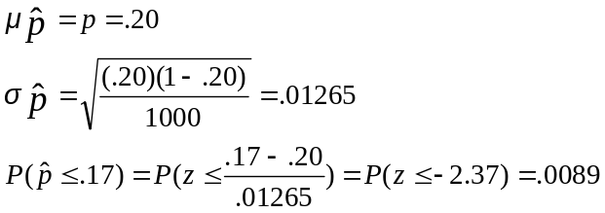

b. Yes, the probability of observing this sample is very small if p = .20. The true p is likely less than .20.

